Classical physics

* Fundamental forces of nature
  + Gravity (infinite/long range)
    - Weak in regular scales
    - Universal (acts on everything that has mass, including light)
    - Non-contact
    - Gravity bends space - Gravity is the curvature of space and time
 $R_{uu}=\frac{1}{2}Rg_{uu}=8πGT_{uu}$

   - Gravity bent time (affects the flow of time)
    - Gravity leads to Black Hole & Singularity
    - Gravity leads to Gravitational waves
    - Gravity is the weakest among all forces
    - Gravity is difficult to reconcile with other forces
    - Gravity is related to information and leads to entropy (the entropy of a black hole is proportional to the area of event horizon)

$S=\frac{kc^{3}A}{4Gh}$ → the equation that includes every aspects of Physics

* + Electromagnetic (infinite/long range), Strong & Weak nuclear forces (short range
* Electricity and Magnetism
  + Charge
    - Conservative quantity
    - Charge is an atom (charge is quantised)
    - $\frac{F_{gravity}}{F_{electricity}}$ → ratio won't change = $\frac{Gm_{1}m_{2}}{Kq_{1}q_{2}}$ which is approximately ${10}^{39}$
  + Electric field
    - Field is a function of time
    - $F=\frac{kqq}{r^{2}}=qE$, $E=\frac{Kq}{r^{2}}$
  + Magnetic field
    - $B=\frac{μ_{0}I}{2πr}$ where $μ_{0}$ is the permittivity of free space
    - How to find magnetic force: RHR
  + Electromagnetic waves
    - An accelerating charge → changing electric field → electromagnetic wave
    - Light is electromagnetic wave
    - The electric and magnetic field are perpendicular to each other
  + Relationship between electricity and magnetism
    - Maxwell’s equation

A changing electric field creates a magnetic field, a changing magnetic field over time creates an electric field

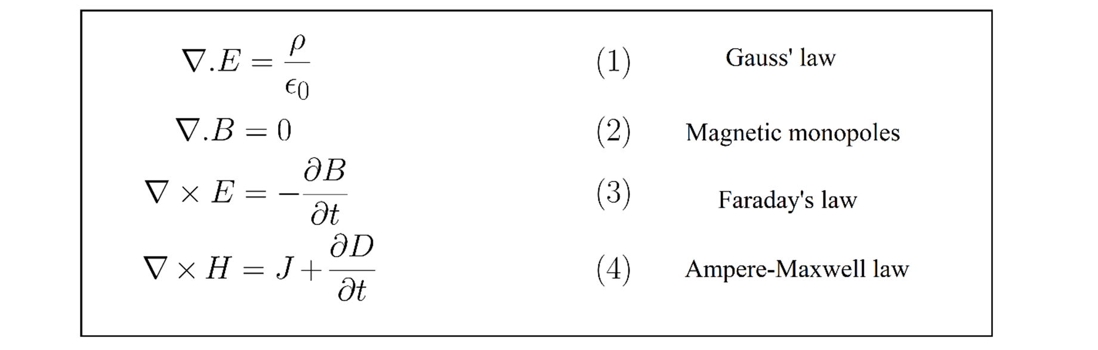

Astrophysics

* Black Hole (lots of mass and energy at a small region)
  + General structure
    - A black hole consists of a singularity (a hypothetical future point in time at which technological growth becomes uncontrollable) in the center where a scalar polynomial constructed from the Riemann curvature tensor diverges towards and the surrounding space-time. Its boundary is a one-way brane that can only enter but not exit: the event horizon.

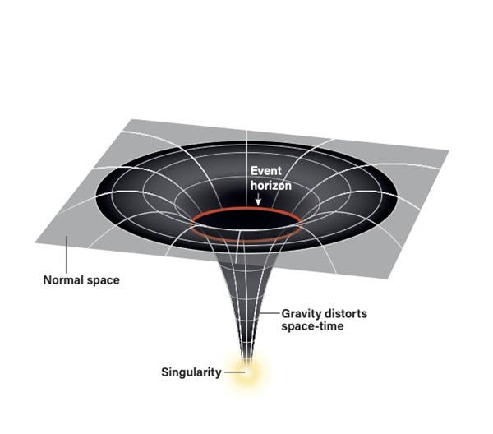

* + Event Horizon
    - When the radius of a planet is smaller than the Schwarzschild radius, it is inside the event horizon. The G would be extremely high and led to a large escape speed. The escape speed is larger than the speed of light, so even light cannot escape once it enters.
  + The formation of a black hole
    - Primordial black hole: formed in the early universe, right after the big bang
    - Stellar black hole: According to Einstein's general theory of relativity, when a dying star collapses, it will collapse toward the center, where it will become a black hole, swallowing all light and any matter in the nearby region of the universe.
    - Gravitational waves: ripples in the fabric of space-time, produced during highly energetic events like neutron star collisions, can be detected by LIGO
* Measuring distance in the cosmos
  + Objects clause by: trigonometric parallax (for objects less than a few thousands light years away

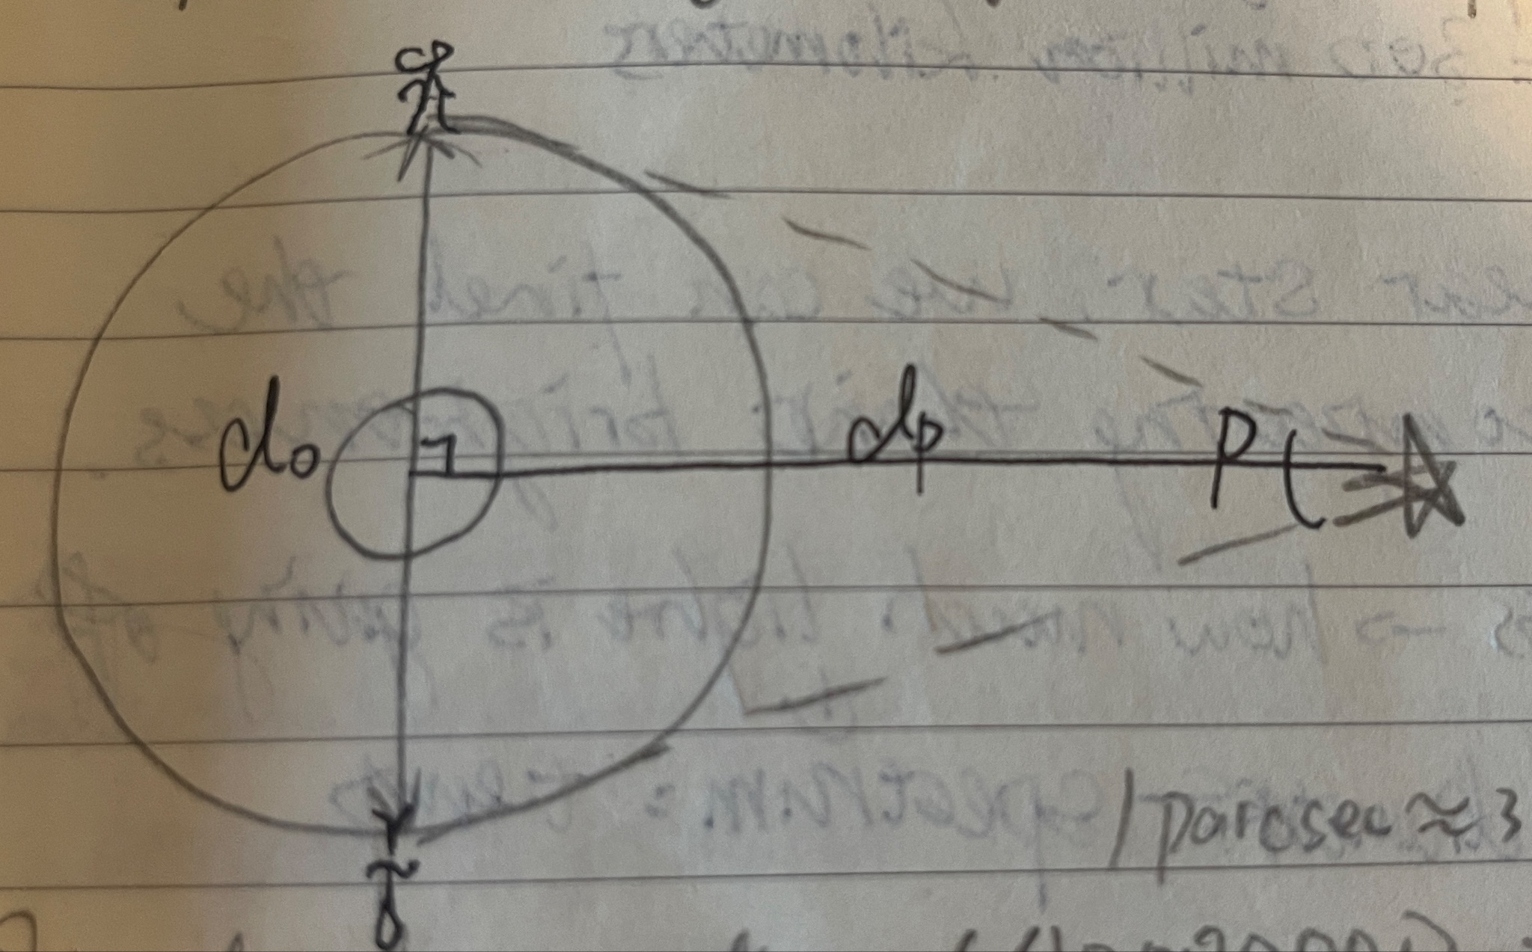

* + Standard candles (for objects 40 million light years away)
    - Cepheid → measuring the period of the cycle, the rate of fluctuations directly related to how bright they are on average
    - Type 1a supernova (for objects several billions light years away)
      * Supernovae: giant stellar explosion → stars die (super bright)
      * Intrinsically bright ones fade slower than fainter ones
      * Using doppler effect
      * Hard to predict a supernovae
* Dark matter
  + The universe is getting bigger and the expansion is speeding up. We expect gravity to pull things together, and therefore slow down the expansion. However, the universe is expanding faster and faster.
  + Dark energy could cause expansion to speed up which contains in 70% of the universe, and it would work in a way opposite to gravity
  + Dark matter does not reflect or transmit light, so we couldn’t see it
  + Two evidence for dark matter
    - Some stars are going so fast that they would be flung out into space, but they stay in their galaxies, so it might be dark matter pulling them towards the center of the galaxy
    - Light bends: sometimes dark matter serve as lenses, bends the space around clusters of galaxies

Quantum Mechanics

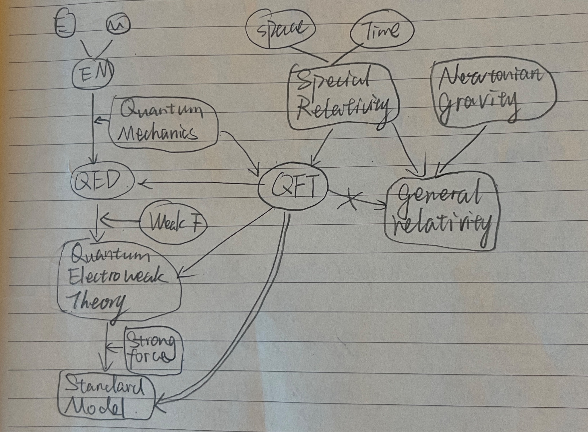

* String theory
  + Currently the most correct theory that explains the universe, including gravity in quantum form
  + Describe different elementary particle as different modes of vibration of the string (higher vibrational mode → higher mass
  + Three advantages of string theory
    - It explains why there are different types of particles
    - It predict they can interact
    - It includes a quantum description of gravity
  + Problems
    - All the strings behave like bosons
    - One of the particle predicted by the theory: tachyon
    - This theory only work in a world with 26D (couldn’t describe our universe)

Particle physics

* Scattering
  + Classical
  + Quantum
  + Quantum Relativism Scattering
* Scattering amplitude: adding up all the possibilities of particles that shows wave-like properties
* Feynman Diagram
  + Instate and outstate
  + Lots of probabilities (super complex) ended up with simple principle, indicating the process of exploring something in physics might be complicated, but eventually something amazing and a pattern will show up
* Quantum Computing
  + Qubit (units of information)
    - A classical bit (cbit) can be 0 or 1
    - A quantum bit (qubit) can be any linear superposition of 0 and 1
    - 1 qubit → 2 coefficient

2 qubits → 4 coefficient

N qubits → $2^{n}$ coefficient

* Manipulate information
  + Unitary operation
  + Circuit models: finite set of gates and operations to operate
* Quantum advantage (ideal quantum circuit)
  + Problems can be solved efficiently with quantum algorithms
    - Integer function
    - Unstructured research
    - Simulation of quantum mechanics
* Noisy intermediate scale quantum devices
  + 50-100 physical bits
  + Grates are noisy
  + No error correction

**Interrelation**

